2019



Airport Management System



**CSE 312 FINAL PROJECT**

**MD. GOLAM RABBANI**

**(171-15-8778)**

**ZANNATUL FERDOUS MOU**

**(171-15-8759)**

**INSTRUCTOR:**

**Mr. ARMAN ASKHARI**

DAFFODIL INTERNATIONAL UNIVERSITY | SPRING 2019

Table of Contents

1. PROJECT DESCRIPTION 2

1.1 Requirements of the system 2

1. ENTITIES 5
2. MAPPING ER DIAGRAM TO RELATIONAL SCHEMA 6
3. ER/EER DIAGRAM 7
4. RELATIONAL SCHEMA 8
5. NORMALIZATION RULES ON DATABASE 9
6. NORMALISED RELATIONAL SCHEMA 10
7. SQL 11
8. STORED PROCEDURE 24
9. TRIGGERS 29
10. BUSINESS RULES 35

# PROJECT DESCRIPTION

**Domain**: Airport Management System

## Requirements of the system:

* The system is based on airport management. Airport management system primarily deals with management of airport, airlines and passengers. The system provides broad overview of underlying operational factors that influence the airport management.
* The database system has the data of all commercial service airports.
* An airport is located in a city.
* All International airlines operating through various countries across the world have their offices located in all major cities and airports they cover. Hence, an airport may have many airline offices.
* Every airline is identified uniquely by an airline code. Airline code is a two-letter airline designator. Airline also has three-digit code which is printed on an air ticket.

Airline Code

|  |  |  |
| --- | --- | --- |
| Airline Name | IATA Airline code/IATA Designator | 3-DIGIT CODE |
| American Airlines | AA | 1 |
| Biman Bangladesh Airlines | BG | 98 |
| Lufthansa | LH | 220 |
| British Airways | BA | 125 |
| Qatar Airways | QR | 157 |
| Jet Airways | 9W | 589 |
| Emirates | EK | 176 |
| Ethiad Airways | EY | 607 |

Reference: <http://www.iata.org/publications/Pages/code-search.aspx>

* Airline companies serve flights.
* Every flight is uniquely identified by a flight code. Flight code is a combination of an airline code and four-digit number.
  + Flight takes off from one airport and lands on another airport. Therefore, most important aspect of a flight is, its source and destination. Source and destination airports are identified using an airport's IATA code.
* International Air Transport Airport code is simply a location identifier. IATA code is a three-letter code designating many airports across the world. These codes are prominently displayed on baggage tags and printed on an air ticket.

Airport Code

|  |  |
| --- | --- |
| Airport Name | IATA Airport code |
| Hazrat Shahjalal International Airport | DAC |
| Louisville International Airport | SDF |
| Dallas/Fort Worth International Airport | DFW |
| Osmani International Airport | ZYL |
| Cox’s Bazar International Airport | CXB |
| San Francisco International Airport | SFO |
| Frankfurt Airport | FRA |
| George Bush Intercontinental Airport | IAH |
| John F. Kennedy International Airport | JFK |
| Tampa International Airport | TPA |

Reference: <http://www.iata.org/publications/Pages/code-search.aspx>

* Flight has an arrival time, departure time, duration. Flight has three types of classes- business, economy and first class.
* Flight can be of two types such non-stop flight and a connecting flight.
* Connecting flight is a flight which takes intermediate stop and changes a flight possibly change of an airline. But we are assuming that connecting flight does not change a flight that is at each stop, after layover time gets over, passengers aboard the same flight
* Flight serves passengers. Flight carries passengers from source to destination.
* A passenger is uniquely identified by a passenger id and a passport number.
  + Every passenger has details such as name, address, age, sex, phone.
* For a passenger to travel by a flight, he needs a ticket. A ticket or air ticket is used to confirm that an individual has reserved a seat on a flight. With the ticket, a passenger is allowed to board the flight.
  + An air ticket has information such as the passenger's name, the issuing airline, ticket number, source, destination, journey date, seat no, class, fare.
  + 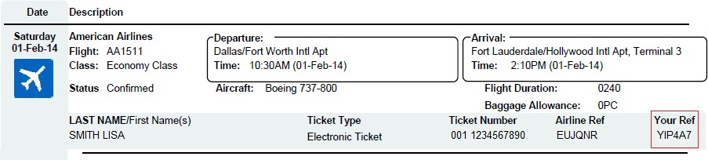Ticket number is the combination of airline's 3-digit code, 4-digit form number, 6-digit serial number.
* Hence, depending on airline, source, destination, journey date and most importantly class, which a passenger chooses fare or price of an air ticket is determined.
* A passenger can book one or multiple tickets. The day on which he books an air ticket is a booking date. Similarly, a passenger can cancel one or multiple tickets. The day on which he cancels an air ticket is cancellation date and there will be a surcharge that a passenger has to pay after cancelling a ticket.
* Every airport has employees working for it.
  + Every employee is identified by SSN. Every employee has an information such name, address, phone, age, sex, salary.
  + Employees in the role of administrative support, engineer, traffic controller and airport authority work at the airport.
  + Every airline needs administrative support staff to keep the office running smoothly. The different positions include secretaries, data entry workers, receptionists, communications and PR specialists and human resources department.
  + There are different types of engineers who work specifically with information technologies, electronics, flight structure, environmental regulations, etc.
  + Traffic Monitor works in different shifts such as day or night.
  + There are different positions that airport authorities might work at such as manager, attendee, assistant, pilot, etc.
* Employees working in the role of administrative support may help passengers with various tasks such as booking a flight ticket, solving passenger's questions, etc.

Assumptions:

* We are not considering privately managed airports. We are only considering publicly owned airports.

Several Categories of airports:

* + - 1. Commercial Service airport

These are publicly owned airports that serve aircrafts which provide scheduled passenger service.

* + - 1. Cargo Service airports

These airports serve aircrafts carrying cargo only

Reference: <http://www.noisequest.psu.edu/aboutairports-typesofairports.html>

* The system is designed only for international flights.
* A city has at most one international airport.
* For Connecting flights, flight and airline remains same at layover stops
* There are different types of jobs available at the airport. For simplicity our system considers a few jobs only.

# ENTITIES

CITY

|  |  |  |
| --- | --- | --- |
| CNAME | STATE | COUNTRY |

AIPORT

|  |  |  |
| --- | --- | --- |
| AP_NAME | STATE | COUNTRY |

AIRLINE

|  |  |  |
| --- | --- | --- |
| AIRLINEID | AL_NAME | THREE_DIGIT_CODE |

FLIGHT

|  |  |  |  |  |  |  |  |
| --- | --- | --- | --- | --- | --- | --- | --- |
| FLIGHT_CODE | SOURCE | DESTINATION | ARRIVAL | DEPARTURE | STATUS | DURATION | FLIGHTTYP |
| LAYOVER_TIME | NO_OF_STOPS |  | | | | | |

PASSENGER

|  |  |  |  |  |  |  |  |  |
| --- | --- | --- | --- | --- | --- | --- | --- | --- |
| PID | PASSPORTNO | FNAME | M | LNAME | ADDRESS | PHONE | AGE | SEX |

TICKET

|  |  |  |  |  |  |  |
| --- | --- | --- | --- | --- | --- | --- |
| TICKET_NUMBER | SOURCE | DESTINATION | DATE_OF_TRAVEL | SEATNO | CLASS | PRICE |

EMPLOYEE

|  |  |  |  |  |  |  |  |  |  |
| --- | --- | --- | --- | --- | --- | --- | --- | --- | --- |
| SSN | FNAME | M | LNAME | ADDRESS | PHONE | AGE | SEX | JOBTYPE | SALARY |

# MAPPING ER DIAGRAM TO RELATIONAL SCHEMA

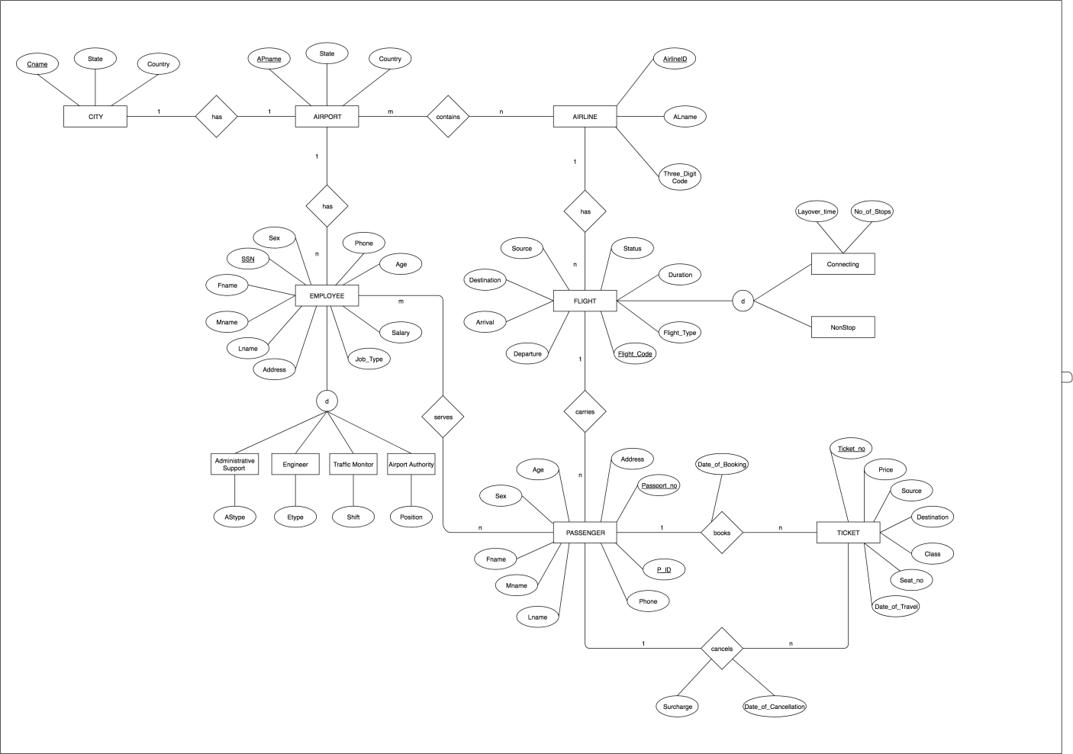

*Figure 1: Airport Management System ER Diagram*

# ER/EER DIAGRAM

ER diagram contains following relationships

|  |  |  |  |
| --- | --- | --- | --- |
| Entity 1 | Name of the Relationship | Entity 2 | Cardinality |
| City | has | Airport | 1:1 |
| Airport | contains | Airline | m : n |
| Airport | has | Employee | 1 : n |
| Airline | has | Flight | 1 : n |
| Flight | carries | Passengers | 1 : n |
| Employee | serves | Passengers | m : n |
| Passenger | books | Ticket | 1 : n |
| Passenger | cancels | Ticket | 1 : n |

|  |  |
| --- | --- |
| Type of the binary relationship | Relationships in the system |
| one-to-one | (1 A city has only one airport. |
| one-to-many | 1. An airline has multiple flights, that is many flights belong to the same airline company. 2. A flight carries many passengers. 3. A passenger can book one or more tickets. 4. A passenger can cancel one or more tickets. |
| many-to-many | All International airlines operating through various countries across the world have their offices located in all major cities and airports they cover. Hence, an  airport may have many airline offices. |

# RELATIONAL SCHEMA

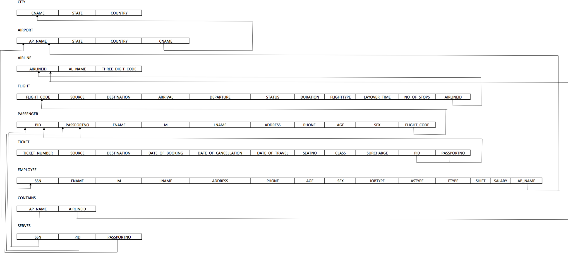

# NORMALIZATION RULES ON DATABASE

|  |  |
| --- | --- |
| FUNCTIONAL DEPENDECIES |  |
| PASSPORTNO -> FNAME, M, LNAME, ADDRESS, PHONE, AGE, SEX | Violates 2NF |
| PID -> FLIGHT_CODE | Violates 2NF |
| DATE_OF_BOOKING, SOURCE, DESTINATION, CLASS -> PRICE | Violates 3NF |
| DATE_OF_CANCELLATION -> SURCHARGE | Violates 3NF |
| JOBTYPE -> SALARY | Violates 3NF |

Normalizing tables into 3NF TABLES AFTER NORMALIZATION

CITY (CNAME, STATE, COUNTRY)

AIRPORT (AP_NAME, STATE, COUNTRY, CNAME)

AIRLINE (AIRLINEID, AL_NAME, THREE_DIGIT_CODE)

CONTAINS (AIRLINEID, AP_NAME)

FLIGHT (FLIGHT_CODE, SOURCE, DESTINATION, ARRIVAL, DEPARTURE, STATUS, DURATION, FLIGHTTYPE, LAYOVER_TIME, NO_OF_STOPS, AIRLINEID)

PASSENGER1 (PID, PASSPORTNO)

PASSENGER2(PASSPORTNO, FNAME, M, LNAME, ADDRESS, PHONE, AGE, SEX)

PASSENGER3 (PID, FLIGHT_CODE)

TICKET1 (TICKET_NUMBER, SOURCE, DESTINATION, DATE_OF_BOOKING, DATE_OF_TRAVEL, SEATNO, CLASS, DATE_OF_CANCELLATION, PID, PASSPORTNO)

TICKET2 (DATE_OF_BOOKING, SOURCE, DESTINATION, CLASS, PRICE)

TICKET3 (DATE_OF_CANCELLATION, SURCHARGE)

EMPLOYEE1 (SSN, FNAME, M, LNAME, ADDRESS, PHONE, AGE, SEX, JOBTYPE, ASTYPE, ETYPE, SHIFT, POSITION, AP_NAME)

EMPLOYEE2(JOBTYPE, SALARY)

SERVES (SSN, PID, PASSPORTNO)

# NORMALISED RELATIONAL SCHEMA

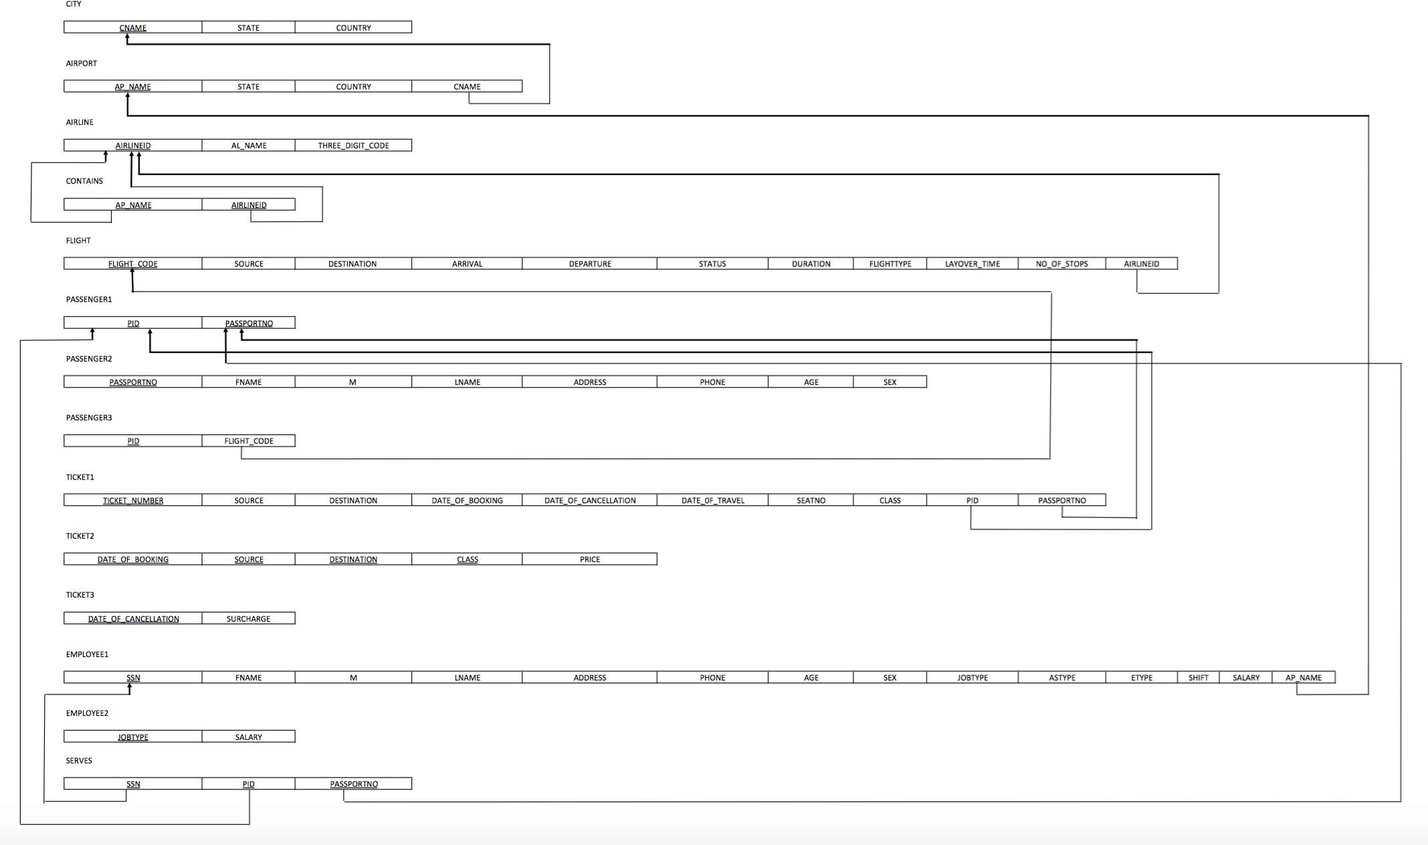

# SQL

### -- Inserting Table: CITY--

CREATE TABLE CITY

(CNAME VARCHAR2(15) NOT NULL, STATE VARCHAR2(15),

COUNTRY VARCHAR(30), PRIMARY KEY(CNAME));

### -- Inserting values of Table: CITY--

INSERT INTO CITY (CNAME, STATE, COUNTRY) VALUES ('Dhaka','Dhaka','Bangladesh');

INSERT INTO CITY (CNAME, STATE, COUNTRY) VALUES('Louisville','Kentucky','United States');

INSERT INTO CITY (CNAME, STATE, COUNTRY) VALUES ('Fort Worth','Texas','United States'); INSERT INTO CITY (CNAME, STATE, COUNTRY) VALUES('Sylhet','Sylhet','Bangladesh');

INSERT INTO CITY (CNAME, STATE, COUNTRY) VALUES('Cox’s Bazar','Cox’s Bazar','Bangladesh');

INSERT INTO CITY (CNAME, STATE, COUNTRY) VALUES('San Francisco', 'California', 'United States'); INSERT INTO CITY (CNAME, STATE, COUNTRY) VALUES('Frankfurt','Hesse','Germany');

INSERT INTO CITY (CNAME, STATE, COUNTRY) VALUES('Houston','Texas','United States');

INSERT INTO CITY (CNAME, STATE, COUNTRY) VALUES('New York City','New York','United States'); INSERT INTO CITY (CNAME, STATE, COUNTRY) VALUES('Tampa', 'Florida', 'United States');

### -- Inserting Table: AIRPORT--

CREATE TABLE AIRPORT

(AP_NAME VARCHAR2(100) NOT NULL, STATE VARCHAR2(15),

COUNTRY VARCHAR(30), CNAME VARCHAR2(15), PRIMARY KEY(AP_NAME),

FOREIGN KEY(CNAME) REFERENCES CITY(CNAME) ON DELETE CASCADE);

### --Inserting values for Table: AIRPORT--

INSERT INTO AIRPORT (AP_NAME, STATE, COUNTRY, CNAME) VALUES('Hazrat Shahjalal International

Airport','Dhaka','Bangladesh','Dhaka');

INSERT INTO AIRPORT (AP_NAME, STATE, COUNTRY, CNAME) VALUES('Louisville International

Airport','Kentucky','United States','Louisville');

INSERT INTO AIRPORT (AP_NAME, STATE, COUNTRY, CNAME) VALUES('Dallas/Fort Worth International Airport','Texas','United States','Fort Worth');

INSERT INTO AIRPORT (AP_NAME, STATE, COUNTRY, CNAME) VALUES('Osmani International

Airport','Sylhet','Bangladesh','Sylhet');

INSERT INTO AIRPORT (AP_NAME, STATE, COUNTRY, CNAME) VALUES('Cox’s Bazar International Airport','Cox’s Bazar','Bangladesh','Cox’s Bazar');

INSERT INTO AIRPORT (AP_NAME, STATE, COUNTRY, CNAME) VALUES('San Francisco International

Airport','California', 'United States','San Francisco');

INSERT INTO AIRPORT (AP_NAME, STATE, COUNTRY, CNAME) VALUES('Frankfurt

Airport','Hesse','Germany','Frankfurt');

INSERT INTO AIRPORT (AP_NAME, STATE, COUNTRY, CNAME) VALUES('George Bush Intercontinental Airport','Texas','United States','Houston');

INSERT INTO AIRPORT (AP_NAME, STATE, COUNTRY, CNAME) VALUES('John F. Kennedy International

Airport','New York','United States','New York City');

INSERT INTO AIRPORT (AP_NAME, STATE, COUNTRY, CNAME) VALUES('Tampa International

Airport','Florida', 'United States','Tampa');

### -- Inserting Table: AIRLINE--

CREATE TABLE AIRLINE

(AIRLINEID VARCHAR(3) NOT NULL, AL_NAME VARCHAR2(50), THREE_DIGIT_CODE VARCHAR(3), PRIMARY KEY(AIRLINEID));

### -- Inserting values for Table: AIRLINE --

INSERT INTO AIRLINE (AIRLINEID, AL_NAME, THREE_DIGIT_CODE) VALUES('BG','Biman Bangladesh Airlines','098');

INSERT INTO AIRLINE (AIRLINEID, AL_NAME, THREE_DIGIT_CODE) VALUES('AA','American Airlines','001');

INSERT INTO AIRLINE (AIRLINEID, AL_NAME, THREE_DIGIT_CODE) VALUES('LH','Lufthansa', '220');

INSERT INTO AIRLINE (AIRLINEID, AL_NAME, THREE_DIGIT_CODE) VALUES('BA','British Airways','125');

INSERT INTO AIRLINE (AIRLINEID, AL_NAME, THREE_DIGIT_CODE) VALUES('QR','Qatar Airways','157'); INSERT INTO AIRLINE (AIRLINEID, AL_NAME, THREE_DIGIT_CODE) VALUES('9W','Jet Airways','589'); INSERT INTO AIRLINE (AIRLINEID, AL_NAME, THREE_DIGIT_CODE) VALUES('EK','Emirates','176');

INSERT INTO AIRLINE (AIRLINEID, AL_NAME, THREE_DIGIT_CODE) VALUES('EY','Ethiad Airways','607');

**-- Inserting Table: CONTAINS--** CREATE TABLE CONTAINS (AIRLINEID VARCHAR(3) NOT NULL,

AP_NAME VARCHAR2(100) NOT NULL, PRIMARY KEY(AIRLINEID, AP_NAME),

FOREIGN KEY(AIRLINEID) REFERENCES AIRLINE(AIRLINEID) ON DELETE CASCADE, FOREIGN KEY(AP_NAME) REFERENCES AIRPORT(AP_NAME) ON DELETE CASCADE);

### -- Inserting values into Table: CONTAINS--

INSERT INTO CONTAINS (AIRLINEID, AP_NAME) VALUES('AA','Louisville International Airport'); INSERT INTO CONTAINS (AIRLINEID, AP_NAME) VALUES('AA','John F. Kennedy International Airport'); INSERT INTO CONTAINS (AIRLINEID, AP_NAME) VALUES('AA','George Bush Intercontinental Airport'); INSERT INTO CONTAINS (AIRLINEID, AP_NAME) VALUES('AA','San Francisco International Airport'); INSERT INTO CONTAINS (AIRLINEID, AP_NAME) VALUES('AA','Tampa International Airport');

INSERT INTO CONTAINS (AIRLINEID, AP_NAME) VALUES('BG','Hazrat Shahjalal International Airport'); INSERT INTO CONTAINS (AIRLINEID, AP_NAME) VALUES('AI','Dallas/Fort Worth International Airport'); INSERT INTO CONTAINS (AIRLINEID, AP_NAME) VALUES('BG','Osmani International Airport');

INSERT INTO CONTAINS (AIRLINEID, AP_NAME) VALUES('AI','Cox’s Bazar International Airport');

INSERT INTO CONTAINS (AIRLINEID, AP_NAME) VALUES('AI','George Bush Intercontinental Airport');

INSERT INTO CONTAINS (AIRLINEID, AP_NAME) VALUES('BG','Cox’s Bazar International Airport');

INSERT INTO CONTAINS (AIRLINEID, AP_NAME) VALUES('LH','Frankfurt Airport');

INSERT INTO CONTAINS (AIRLINEID, AP_NAME) VALUES('LH','John F. Kennedy International Airport'); INSERT INTO CONTAINS (AIRLINEID, AP_NAME) VALUES('LH','San Francisco International Airport'); INSERT INTO CONTAINS (AIRLINEID, AP_NAME) VALUES('LH','Dallas/Fort Worth International Airport');

INSERT INTO CONTAINS (AIRLINEID, AP_NAME) VALUES('BA','John F. Kennedy International Airport'); INSERT INTO CONTAINS (AIRLINEID, AP_NAME) VALUES('BG','Cox’s Bazar International Airport'); INSERT INTO CONTAINS (AIRLINEID, AP_NAME) VALUES('BG','Hazrat Shahjalal International Airport'); INSERT INTO CONTAINS (AIRLINEID, AP_NAME) VALUES('BA','Frankfurt Airport');

INSERT INTO CONTAINS (AIRLINEID, AP_NAME) VALUES('BA','San Francisco International Airport');

INSERT INTO CONTAINS (AIRLINEID, AP_NAME) VALUES('BG','Cox’s Bazar International Airport');

INSERT INTO CONTAINS (AIRLINEID, AP_NAME) VALUES('QR','Dallas/Fort Worth International Airport'); INSERT INTO CONTAINS (AIRLINEID, AP_NAME) VALUES('QR','John F. Kennedy International Airport'); INSERT INTO CONTAINS (AIRLINEID, AP_NAME) VALUES('QR','Tampa International Airport');

INSERT INTO CONTAINS (AIRLINEID, AP_NAME) VALUES('QR','Louisville International Airport');

### -- Inserting Table: FLIGHT--

CREATE TABLE FLIGHT

(FLIGHT_CODE VARCHAR(10) NOT NULL, SOURCE VARCHAR(3),

DESTINATION VARCHAR(3), ARRIVAL VARCHAR2(10), DEPARTURE VARCHAR2(10),

STATUS VARCHAR(10), DURATION VARCHAR2(30), FLIGHTTYPE VARCHAR(10), LAYOVER_TIME VARCHAR2(30), NO_OF_STOPS INT,

AIRLINEID VARCHAR(3), PRIMARY KEY(FLIGHT_CODE),

FOREIGN KEY(AIRLINEID) REFERENCES AIRLINE(AIRLINEID) ON DELETE CASCADE);

### -- Inserting values into Table: FLIGHT—

INSERT INTO FLIGHT(FLIGHT_CODE, SOURCE, DESTINATION, ARRIVAL, DEPARTURE, STATUS, DURATION, FLIGHTTYPE, LAYOVER_TIME, NO_OF_STOPS, AIRLINEID) VALUES('AI2014','DAC','DFW','02:10','03:15','On-time','24hr','Connecting',3,1,'AI');

INSERT INTO FLIGHT(FLIGHT_CODE, SOURCE, DESTINATION, ARRIVAL, DEPARTURE, STATUS, DURATION, FLIGHTTYPE, LAYOVER_TIME, NO_OF_STOPS, AIRLINEID) VALUES('QR2305','DAC','DFW','13:00','13:55','Delayed','21hr','Non-stop',0,0,'QR');

INSERT INTO FLIGHT(FLIGHT_CODE, SOURCE, DESTINATION, ARRIVAL, DEPARTURE, STATUS, DURATION, FLIGHTTYPE, LAYOVER_TIME, NO_OF_STOPS, AIRLINEID)

VALUES('EY1234','JFK','TPA','19:20','20:05','On-time','16hrs','Connecting',5,2,'EY');

INSERT INTO FLIGHT(FLIGHT_CODE, SOURCE, DESTINATION, ARRIVAL, DEPARTURE, STATUS, DURATION, FLIGHTTYPE, LAYOVER_TIME, NO_OF_STOPS, AIRLINEID) VALUES('LH9876','JFK','CXB','05:50','06:35','On-time','18hrs','Non-stop',0,0,'LH');

INSERT INTO FLIGHT(FLIGHT_CODE, SOURCE, DESTINATION, ARRIVAL, DEPARTURE, STATUS, DURATION, FLIGHTTYPE, LAYOVER_TIME, NO_OF_STOPS, AIRLINEID) VALUES('BA1689','FRA','ZYL','10:20','10:55','On-time','14hrs','Non-stop',0,0,'BA');

INSERT INTO FLIGHT(FLIGHT_CODE, SOURCE, DESTINATION, ARRIVAL, DEPARTURE, STATUS, DURATION, FLIGHTTYPE, LAYOVER_TIME, NO_OF_STOPS, AIRLINEID) VALUES('AA4367','SFO','FRA','18:10','18:55','On-time','21hrs','Non-stop',0,0,'AA');

INSERT INTO FLIGHT(FLIGHT_CODE, SOURCE, DESTINATION, ARRIVAL, DEPARTURE, STATUS, DURATION, FLIGHTTYPE, LAYOVER_TIME, NO_OF_STOPS, AIRLINEID) VALUES('QR1902','CXB','IAH','22:00','22:50','Delayed','28hrs','Non-stop',5,1,'QR');

INSERT INTO FLIGHT(FLIGHT_CODE, SOURCE, DESTINATION, ARRIVAL, DEPARTURE, STATUS, DURATION, FLIGHTTYPE, LAYOVER_TIME, NO_OF_STOPS, AIRLINEID)

VALUES('BA3056','DAC','DFW','02:15','02:55','On-time','29hrs','Connecting',3,1,'BA');

INSERT INTO FLIGHT(FLIGHT_CODE, SOURCE, DESTINATION, ARRIVAL, DEPARTURE, STATUS, DURATION, FLIGHTTYPE, LAYOVER_TIME, NO_OF_STOPS, AIRLINEID) VALUES('EK3456','DAC','SFO','18:50','19:40','On-time','30hrs','Non-stop',0,0,'EK');

INSERT INTO FLIGHT(FLIGHT_CODE, SOURCE, DESTINATION, ARRIVAL, DEPARTURE, STATUS, DURATION, FLIGHTTYPE, LAYOVER_TIME, NO_OF_STOPS, AIRLINEID) VALUES('9W2334','IAH','ZYL','23:00','13:45','On-time','23hrs','Direct',0,0,'9W');

### -- Inserting Table: PASSENGER1--

CREATE TABLE PASSENGER1 (PID INT NOT NULL,

PASSPORTNO VARCHAR(10) NOT NULL, PRIMARY KEY(PID, PASSPORTNO));

### -- Inserting values in table: PASSENGER1--

INSERT INTO PASSENGER1(PID, PASSPORTNO) VALUES(1,'A1234568'); INSERT INTO PASSENGER1(PID, PASSPORTNO) VALUES(2,'B9876541'); INSERT INTO PASSENGER1(PID, PASSPORTNO) VALUES(3,'C2345698'); INSERT INTO PASSENGER1(PID, PASSPORTNO) VALUES(4,'D1002004'); INSERT INTO PASSENGER1(PID, PASSPORTNO) VALUES(5,'X9324666'); INSERT INTO PASSENGER1(PID, PASSPORTNO) VALUES(6,'B8765430'); INSERT INTO PASSENGER1(PID, PASSPORTNO) VALUES(7,'J9801235'); INSERT INTO PASSENGER1(PID, PASSPORTNO) VALUES(8,'A1122334'); INSERT INTO PASSENGER1(PID, PASSPORTNO) VALUES(9,'Q1243567'); INSERT INTO PASSENGER1(PID, PASSPORTNO) VALUES(10,'S1243269'); INSERT INTO PASSENGER1(PID, PASSPORTNO) VALUES(11,'E3277889'); INSERT INTO PASSENGER1(PID, PASSPORTNO) VALUES(12,'K3212322'); INSERT INTO PASSENGER1(PID, PASSPORTNO) VALUES(13,'P3452390'); INSERT INTO PASSENGER1(PID, PASSPORTNO) VALUES(14,'W7543336'); INSERT INTO PASSENGER1(PID, PASSPORTNO) VALUES(15,'R8990566');

### -- Inserting Table: PASSENGER2--

CREATE TABLE PASSENGER2 (PASSPORTNO VARCHAR(10) NOT NULL, FNAME VARCHAR2(20),

M VARCHAR(1), LNAME VARCHAR2(20),

ADDRESS VARCHAR2(100), PHONE INT,

AGE INT,

SEX VARCHAR(1),

PRIMARY KEY(PASSPORTNO));

### --Inserting VALUES IN TABLE: PASSENGER2--

INSERT INTO PASSENGER2(PASSPORTNO,FNAME,M,LNAME,ADDRESS,PHONE,AGE,SEX) VALUES(A1234568','GOLAM','M','RABBANI','WEST RAJA BAZAR TEJGON, DHAKA 1215',

8801723910526,22,'M');

INSERT INTO PASSENGER2(PASSPORTNO,FNAME,M,LNAME,ADDRESS,PHONE,AGE,SEX) VALUES('B9876541','ZANNATUL','FERDOUS','MOU','W MALIBAGH, DHAKA 1205',8801632564343,26,'F');

INSERT INTO PASSENGER2(PASSPORTNO,FNAME,M,LNAME,ADDRESS,PHONE,AGE,SEX) VALUES('C2345698','FARHANA','A','AFRIN','WESTRAJABAZARTEJGON,DHAKA1215',880182267280,30,'F');

INSERT INTO PASSENGER2(PASSPORTNO,FNAME,M,LNAME,ADDRESS,PHONE,AGE,SEX) VALUES('D1002004','SHIMUL','S','PARVEZ','NEW ELEPHANT ROAD, DHAKA 1205',880180367266,23,'M');

INSERT INTO PASSENGER2(PASSPORTNO,FNAME,M,LNAME,ADDRESS,PHONE,AGE,SEX) VALUES('X9324666','RASHID','B','ARIF','SHAHBAGH, DHAKA 1206, BANGLADESH',8801704360125,28,'M'');

INSERT INTO PASSENGER2(PASSPORTNO,FNAME,M,LNAME,ADDRESS,PHONE,AGE,SEX) VALUES('B8765430','ERINA','P','KABIR','SHAMOLI BANGLA RESORT, DHAKA 1207, BANGLADESH',8801666190505,30,'F');

INSERT INTO PASSENGER2(PASSPORTNO,FNAME,M,LNAME,ADDRESS,PHONE,AGE,SEX) VALUES('J9801235','TAZEEN','D','EHSAN','SHUKRABAD,DHANMONDI,DHAKA,BANGLADESH',880180369290,29,'M');

INSERT INTO PASSENGER2(PASSPORTNO,FNAME,M,LNAME,ADDRESS,PHONE,AGE,SEX) VALUES('A1122334','SHUBORNA','S','PAOUL','WEST RAJA BAZAR TEJGON, DHAKA 1215',880194335126,25,'F');

INSERT INTO PASSENGER2(PASSPORTNO,FNAME,M,LNAME,ADDRESS,PHONE,AGE,SEX) VALUES('Q1243567','MEHEDI','M','HASAN','WEST RAJA BAZAR TEJGON, DHAKA 1215',8801727626643,22,'M');

INSERT INTO PASSENGER2(PASSPORTNO,FNAME,M,LNAME,ADDRESS,PHONE,AGE,SEX) VALUES('S1243269','MOSIUR','A','WEST RAJA BAZAR TEJGON, DHAKA 1215',8801504568903,60,'M');

INSERT INTO PASSENGER2(PASSPORTNO,FNAME,M,LNAME,ADDRESS,PHONE,AGE,SEX) VALUES('E3277889','MAHMUDUL','A','HASAN','WEST RAJA BAZAR TEJGON, DHAKA 1215',9724569986,10,'M');

INSERT INTO PASSENGER2(PASSPORTNO,FNAME,M,LNAME,ADDRESS,PHONE,AGE,SEX) VALUES('K3212322','ROBIN','B','ISLAM','WEST RAJA BAZAR TEJGON, DHAKA 1215',9024569226,15,'M');

INSERT INTO PASSENGER2(PASSPORTNO,FNAME,M,LNAME,ADDRESS,PHONE,AGE,SEX) VALUES('P3452390','RUBEL','V','HOSEN','W MALIBAGH, DHAKA 1205',9734567800,10,'M');

INSERT INTO PASSENGER2(PASSPORTNO,FNAME,M,LNAME,ADDRESS,PHONE,AGE,SEX) VALUES('W7543336','KANIZ','P','FATEMA','W MALIBAGH, DHAKA 1205',4624569986,55,'F');

INSERT INTO PASSENGER2(PASSPORTNO,FNAME,M,LNAME,ADDRESS,PHONE,AGE,SEX) VALUES('R8990566','AVRO','T','HASAN','MIRPUR 10, DHAKA 1205',4724512343,10,'M');

### -- Inserting Table: PASSENGER3--

CREATE TABLE PASSENGER3 (PID INT NOT NULL, FLIGHT_CODE VARCHAR(10), PRIMARY KEY(PID),

FOREIGN KEY(FLIGHT_CODE) REFERENCES FLIGHT(FLIGHT_CODE) ON DELETE CASCADE);

### -- Inserting values into Table: PASSENGER3--

INSERT INTO PASSENGER3(PID, FLIGHT_CODE) VALUES(1,'AI2014'); INSERT INTO PASSENGER3(PID, FLIGHT_CODE) VALUES(2,'LH9876'); INSERT INTO PASSENGER3(PID, FLIGHT_CODE) VALUES(3,'9W2334'); INSERT INTO PASSENGER3(PID, FLIGHT_CODE) VALUES(4,'QR1902'); INSERT INTO PASSENGER3(PID, FLIGHT_CODE) VALUES(5,'EY1234'); INSERT INTO PASSENGER3(PID, FLIGHT_CODE) VALUES(6,'BA3056'); INSERT INTO PASSENGER3(PID, FLIGHT_CODE) VALUES(7,'9W2334'); INSERT INTO PASSENGER3(PID, FLIGHT_CODE) VALUES(8,'AA4367'); INSERT INTO PASSENGER3(PID, FLIGHT_CODE) VALUES(9,'QR1902'); INSERT INTO PASSENGER3(PID, FLIGHT_CODE) VALUES(10,'EK3456'); INSERT INTO PASSENGER3(PID, FLIGHT_CODE) VALUES(11,'BA1689'); INSERT INTO PASSENGER3(PID, FLIGHT_CODE) VALUES(12,'QR1902'); INSERT INTO PASSENGER3(PID, FLIGHT_CODE) VALUES(13,'AI2014'); INSERT INTO PASSENGER3(PID, FLIGHT_CODE) VALUES(14,'BA1689'); INSERT INTO PASSENGER3(PID, FLIGHT_CODE) VALUES(15,'QR2305');

### -- Inserting Table: EMPLOYEE1—

CREATE TABLE EMPLOYEE1 (SSN INT NOT NULL, FNAME VARCHAR2(20),

M VARCHAR(1), LNAME VARCHAR2(20),

ADDRESS VARCHAR2(100), PHONE INT,

AGE INT,

SEX VARCHAR(1), JOBTYPE VARCHAR2(30), ASTYPE VARCHAR2(30), ETYPE VARCHAR2(30), SHIFT VARCHAR2(20), POSITION VARCHAR2(30),

AP_NAME VARCHAR2(100), PRIMARY KEY(SSN),

FOREIGN KEY(AP_NAME) REFERENCES AIRPORT(AP_NAME) ON DELETE CASCADE);

### -- Implementing Business Rule Using Check Constraint--

AGE OF AN EMPLOYEE WORKING FOR AN AIRPORT SHOULD NOT BE GREATER THAN 65--

ALTER TABLE EMPLOYEE1

ADD CONSTRAINT AGE_LIMIT CHECK(AGE < 65);

### -- Example Of Violation Of Check Constraint--

INSERT INTO EMPLOYEE1(SSN, FNAME, M, LNAME, ADDRESS, PHONE, AGE, SEX, JOBTYPE, ASTYPE, ETYPE, SHIFT, POSITION, AP_NAME)

VALUES(123456799,'RAHAT','M','HASAN','731 HILL TOWN, ARLINGTON, TX',4356789365, 66,

'M','ADMINISTRATIVE SUPPORT','RECEPTIONIST','','','','Louisville International Airport');

### -- Inserting values in table: EMPLOYEE1 --

INSERT INTO EMPLOYEE1(SSN, FNAME, M, LNAME, ADDRESS, PHONE, AGE, SEX, JOBTYPE, ASTYPE, ETYPE, SHIFT, POSITION, AP_NAME)

VALUES(123456789,'LINDA','M','GOODMAN','731 Fondren, Houston, TX',4356789345, 35,

'F','ADMINISTRATIVE SUPPORT','RECEPTIONIST','','','','Louisville International Airport');

INSERT INTO EMPLOYEE1(SSN, FNAME, M, LNAME, ADDRESS, PHONE, AGE, SEX, JOBTYPE, ASTYPE, ETYPE, SHIFT, POSITION, AP_NAME)

VALUES(333445555,'JOHNY','N','PAUL','638 Voss, Houston, TX',9834561995, 40, 'M','ADMINISTRATIVE

SUPPORT','SECRETARY','','','','Louisville International Airport');

INSERT INTO EMPLOYEE1(SSN, FNAME, M, LNAME, ADDRESS, PHONE, AGE, SEX, JOBTYPE, ASTYPE, ETYPE, SHIFT, POSITION, AP_NAME)

VALUES(999887777,'JAMES','P','BOND','3321 Castle, Spring, TX',9834666995, 50,

'M','ENGINEER','','RADIO ENGINEER','','','Louisville International Airport');

INSERT INTO EMPLOYEE1(SSN, FNAME, M, LNAME, ADDRESS, PHONE, AGE, SEX, JOBTYPE, ASTYPE, ETYPE, SHIFT, POSITION, AP_NAME)

VALUES(987654321,'SHERLOCK','A','HOLMES','123 TOP HILL, SAN Francisco,CA',8089654321, 47,

'M','TRAFFIC MONITOR','','','DAY','','San Francisco International Airport');

INSERT INTO EMPLOYEE1(SSN, FNAME, M, LNAME, ADDRESS, PHONE, AGE, SEX, JOBTYPE, ASTYPE, ETYPE, SHIFT, POSITION, AP_NAME)

VALUES(666884444,'SHELDON','A','COOPER','345 CHERRY PARK, HESSE,GERMANY',1254678903, 55, 'M','TRAFFIC MONITOR','','NIGHT','','','Frankfurt Airport');

INSERT INTO EMPLOYEE1(SSN, FNAME, M, LNAME, ADDRESS, PHONE, AGE, SEX, JOBTYPE, ASTYPE, ETYPE, SHIFT, POSITION, AP_NAME)

VALUES(453453453,'RAKIBUL','B','ISLAM','COX’S BAZAR, COX’S BAZAR ,BANGLADESH',4326789031,

35, 'M','AIRPORT AUTHORITY','','','','MANAGER','Cox’s Bazar International Airport');

INSERT INTO EMPLOYEE1(SSN, FNAME, M, LNAME, ADDRESS, PHONE, AGE, SEX, JOBTYPE, ASTYPE, ETYPE, SHIFT, POSITION, AP_NAME)

VALUES(987987987,'NIKITA','C','PAUL','110 SYNERGY PARK, DALLAS,TX',5678904325, 33,

'F','ENGINEER','','AIRPORT CIVIL ENGINEER','','','Dallas/Fort Worth International Airport');

INSERT INTO EMPLOYEE1(SSN, FNAME, M, LNAME, ADDRESS, PHONE, AGE, SEX, JOBTYPE, ASTYPE, ETYPE, SHIFT, POSITION, AP_NAME)

VALUES(888665555,'IMTIAJ','R','ALNAFIS','SYLHET, SYLHET, BANGLADESH',8566778890, 39,

'M','ADMINISTRATIVE SUPPORT','DATA ENTRY WORKER','','','','Osmani International Airport');

INSERT INTO EMPLOYEE1(SSN, FNAME, M, LNAME, ADDRESS, PHONE, AGE, SEX, JOBTYPE, ASTYPE, ETYPE, SHIFT, POSITION, AP_NAME)

VALUES(125478909,'PRATIK','T','GOMES','334 VITRUVIAN PARK, ALBANY, NY',4444678903, 56,

'M','TRAFFIC MONITOR','','DAY','','','John F. Kennedy International Airport');

INSERT INTO EMPLOYEE1(SSN, FNAME, M, LNAME, ADDRESS, PHONE, AGE, SEX, JOBTYPE, ASTYPE, ETYPE, SHIFT, POSITION, AP_NAME)

VALUES(324567897,'ASADUL','P','ISLAM','DHAKA, DHAKA, BANGLADESH',2244658909, 36,

'M','TRAFFIC MONITOR','','DAY','','','Hazrat Shahjalal International Airport');

### -- Inserting Table: EMPLOYEE2 --

CREATE TABLE EMPLOYEE2 (JOBTYPE VARCHAR2(30) NOT NULL, SALARY INT,

PRIMARY KEY(JOBTYPE));

### --INSERTING VALUES INTO TABLE: EMPLOYEE2 --

INSERT INTO EMPLOYEE2(JOBTYPE, SALARY)VALUES('ADMINISTRATIVE SUPPORT',50000); INSERT INTO EMPLOYEE2(JOBTYPE, SALARY)VALUES('ENGINEER',70000);

INSERT INTO EMPLOYEE2(JOBTYPE, SALARY)VALUES('TRAFFIC MONITOR',80000); INSERT INTO EMPLOYEE2(JOBTYPE, SALARY)VALUES('AIRPORT AUTHORITY',90000);

### -- Inserting Table: SERVES --

CREATE TABLE SERVES (SSN INT NOT NULL, PID INT NOT NULL,

PASSPORTNO VARCHAR(10) NOT NULL, PRIMARY KEY(SSN, PID, PASSPORTNO),

FOREIGN KEY(SSN) REFERENCES EMPLOYEE1(SSN) ON DELETE CASCADE,

FOREIGN KEY(PID, PASSPORTNO) REFERENCES PASSENGER1(PID, PASSPORTNO) ON DELETE CASCADE);

### -- INSERTING VALUES INTO TABLE: SERVES --

INSERT INTO SERVES(SSN, PID, PASSPORTNO) VALUES(123456789,1,'A1234568'); INSERT INTO SERVES(SSN, PID, PASSPORTNO) VALUES(123456789,15,'R8990566'); INSERT INTO SERVES(SSN, PID, PASSPORTNO) VALUES(123456789,9,'Q1243567'); INSERT INTO SERVES(SSN, PID, PASSPORTNO) VALUES(888665555,4,'D1002004'); INSERT INTO SERVES(SSN, PID, PASSPORTNO) VALUES(888665555,13,'P3452390'); INSERT INTO SERVES(SSN, PID, PASSPORTNO) VALUES(333445555,10,'S1243269'); INSERT INTO SERVES(SSN, PID, PASSPORTNO) VALUES(333445555,12,'K3212322'); INSERT INTO SERVES(SSN, PID, PASSPORTNO) VALUES(888665555,12,'K3212322'); INSERT INTO SERVES(SSN, PID, PASSPORTNO) VALUES(123456789,7,'J9801235'); INSERT INTO SERVES(SSN, PID, PASSPORTNO) VALUES(888665555,7,'J9801235');

### -- Inserting Table: TICKET1 --

CREATE TABLE TICKET1

(TICKET_NUMBER VARCHAR(13) NOT NULL, SOURCE VARCHAR(3),

DESTINATION VARCHAR(3), DATE_OF_BOOKING DATE, DATE_OF_TRAVEL DATE, SEATNO VARCHAR(5), CLASS VARCHAR2(15),

DATE_OF_CANCELLATION DATE, PID INT,

PASSPORTNO VARCHAR(10),

FOREIGN KEY(PID, PASSPORTNO) REFERENCES PASSENGER1(PID, PASSPORTNO) ON DELETE CASCADE);

### -- Adding CHECK constraint on an attribute TICKET_NUMBER --

ALTER TABLE TICKET1

ADD CONSTRAINT TICKET_NO_LENGTH CHECK(LENGTH(TICKET_NUMBER)=13);

### -- Checking Violation Of A Constraint--

INSERT INTO TICKET1(TICKET_NUMBER, SOURCE, DESTINATION, DATE_OF_BOOKING, DATE_OF_CANCELLATION, DATE_OF_TRAVEL, SEATNO, CLASS, PID, PASSPORTNO) VALUES(00112341111221,'BOM','DFW','11-MAY-19','','15-DEC-19','32A','ECONOMY',1,'A1234568');

### -- Inserting values into Table: TICKET1--

--INSERTING INTO TABLE: TICKET1--

INSERT INTO TICKET1(TICKET_NUMBER, SOURCE, DESTINATION, DATE_OF_BOOKING, DATE_OF_CANCELLATION, DATE_OF_TRAVEL, SEATNO, CLASS, PID, PASSPORTNO) VALUES(0011234111122,'BOM','DFW','11-MAY-19','','15-DEC-19','32A','ECONOMY',1,'A1234568');

INSERT INTO TICKET1(TICKET_NUMBER, SOURCE, DESTINATION, DATE_OF_BOOKING, DATE_OF_CANCELLATION, DATE_OF_TRAVEL, SEATNO, CLASS, PID, PASSPORTNO) VALUES(0984567222299,'JFK','BOM','11-JUN-19','10-DEC-19','20-DEC- 19','45D','ECONOMY',2,'B9876541');

INSERT INTO TICKET1(TICKET_NUMBER, SOURCE, DESTINATION, DATE_OF_BOOKING, DATE_OF_CANCELLATION, DATE_OF_TRAVEL, SEATNO, CLASS, PID, PASSPORTNO) VALUES(1768901333273,'IAH','DEL','21-AUG-19','','25-DEC-19','1A','BUSINESS',3,'C2345698');

INSERT INTO TICKET1(TICKET_NUMBER, SOURCE, DESTINATION, DATE_OF_BOOKING, DATE_OF_CANCELLATION, DATE_OF_TRAVEL, SEATNO, CLASS, PID, PASSPORTNO) VALUES(5890987441464,'IXC','IAH','10-AUG-19','','12-JAN-20','20C','FIRST-CLASS',4,'D1002004');

INSERT INTO TICKET1(TICKET_NUMBER, SOURCE, DESTINATION, DATE_OF_BOOKING, DATE_OF_CANCELLATION, DATE_OF_TRAVEL, SEATNO, CLASS, PID, PASSPORTNO) VALUES(1577654664266,'JFK','TPA','13-JUN-19','','10-DEC-19','54E','ECONOMY',5,'X9324666');

INSERT INTO TICKET1(TICKET_NUMBER, SOURCE, DESTINATION, DATE_OF_BOOKING, DATE_OF_CANCELLATION, DATE_OF_TRAVEL, SEATNO, CLASS, PID, PASSPORTNO) VALUES(2206543545545,'BOM','DFW','11-NOV-19','','12-FEB-20','43B','ECONOMY',6,'B8765430');

INSERT INTO TICKET1(TICKET_NUMBER, SOURCE, DESTINATION, DATE_OF_BOOKING, DATE_OF_CANCELLATION, DATE_OF_TRAVEL, SEATNO, CLASS, PID, PASSPORTNO) VALUES(7064321779737,'IAH','DEL','15-NOV-19','','25-DEC-19','27B','FIRST-CLASS',7,'J9801235');

INSERT INTO TICKET1(TICKET_NUMBER, SOURCE, DESTINATION, DATE_OF_BOOKING, DATE_OF_CANCELLATION, DATE_OF_TRAVEL, SEATNO, CLASS, PID, PASSPORTNO) VALUES(1571357215116,'SFO','FRA','15-OCT-19','','18-DEC-19','34E','ECONOMY',8,'A1122334');

INSERT INTO TICKET1(TICKET_NUMBER, SOURCE, DESTINATION, DATE_OF_BOOKING, DATE_OF_CANCELLATION, DATE_OF_TRAVEL, SEATNO, CLASS, PID, PASSPORTNO) VALUES(1570864987655,'IXC','IAH','12-NOV-19','','30-DEC-19','54C','ECONOMY',9,'Q1243567');

INSERT INTO TICKET1(TICKET_NUMBER, SOURCE, DESTINATION, DATE_OF_BOOKING, DATE_OF_CANCELLATION, DATE_OF_TRAVEL, SEATNO, CLASS, PID, PASSPORTNO) VALUES(1579283997799,'BOM','SFO','22-JAN-19','','15-DEC-19','38A','ECONOMY',10,'S1243269');

INSERT INTO TICKET1(TICKET_NUMBER, SOURCE, DESTINATION, DATE_OF_BOOKING, DATE_OF_CANCELLATION, DATE_OF_TRAVEL, SEATNO, CLASS, PID, PASSPORTNO) VALUES(1255701876107,'FRA','DEL','19-OCT-19','','31-DEC-19','57F','ECONOMY',11,'E3277889');

INSERT INTO TICKET1(TICKET_NUMBER, SOURCE, DESTINATION, DATE_OF_BOOKING, DATE_OF_CANCELLATION, DATE_OF_TRAVEL, SEATNO, CLASS, PID, PASSPORTNO) VALUES(1251334499699,'IXC','IAH','20-NOV-19','','12-JAN-20','45D','ECONOMY',12,'K3212322');

INSERT INTO TICKET1(TICKET_NUMBER, SOURCE, DESTINATION, DATE_OF_BOOKING, DATE_OF_CANCELLATION, DATE_OF_TRAVEL, SEATNO, CLASS, PID, PASSPORTNO) VALUES(1258776199490,'BOM','DFW','13-MAY-19','25-MAY-19','15-DEC- 19','37C','ECONOMY',13,'P3452390');

INSERT INTO TICKET1(TICKET_NUMBER, SOURCE, DESTINATION, DATE_OF_BOOKING, DATE_OF_CANCELLATION, DATE_OF_TRAVEL, SEATNO, CLASS, PID, PASSPORTNO) VALUES(5891155114477,'FRA','DEL','26-JUN-19','','23-DEC-19','55C','ECONOMY',14,'W7543336');

INSERT INTO TICKET1(TICKET_NUMBER, SOURCE, DESTINATION, DATE_OF_BOOKING, DATE_OF_CANCELLATION, DATE_OF_TRAVEL, SEATNO, CLASS, PID, PASSPORTNO) VALUES(5893069766787,'BOM','DFW','11-AUG-19','','22-DEC-19','33F','ECONOMY',15,'R8990566');

### -- Inserting Table: TICKET2--

CREATE TABLE TICKET2 (DATE_OF_BOOKING DATE NOT NULL, SOURCE VARCHAR(3) NOT NULL, DESTINATION VARCHAR(3) NOT NULL, CLASS VARCHAR2(15) NOT NULL, PRICE INT,

PRIMARY KEY(DATE_OF_BOOKING, SOURCE, DESTINATION, CLASS));

### -- Inserting Values into: TICKET2 --

INSERT INTO TICKET2(DATE_OF_BOOKING, SOURCE, DESTINATION, CLASS, PRICE) VALUES('11-MAY-19','BOM','DFW','ECONOMY',95000);

INSERT INTO TICKET2(DATE_OF_BOOKING, SOURCE, DESTINATION, CLASS, PRICE) VALUES('11-JUN-19','JFK','BOM','ECONOMY',100000);

INSERT INTO TICKET2(DATE_OF_BOOKING, SOURCE, DESTINATION, CLASS, PRICE) VALUES('21-AUG-19','IAH','DEL','BUSINESS',200000);

INSERT INTO TICKET2(DATE_OF_BOOKING, SOURCE, DESTINATION, CLASS, PRICE) VALUES('10-AUG-19','IXC','IAH','FIRST-CLASS',150000);

INSERT INTO TICKET2(DATE_OF_BOOKING, SOURCE, DESTINATION, CLASS, PRICE) VALUES('13-JUN-19','JFK','TPA','ECONOMY',98000);

INSERT INTO TICKET2(DATE_OF_BOOKING, SOURCE, DESTINATION, CLASS, PRICE) VALUES('11-NOV-19','BOM','DFW','ECONOMY',125000);

INSERT INTO TICKET2(DATE_OF_BOOKING, SOURCE, DESTINATION, CLASS, PRICE) VALUES('15-NOV-19,'IAH','ZYL','FIRST-CLASS',195000);

INSERT INTO TICKET2(DATE_OF_BOOKING, SOURCE, DESTINATION, CLASS, PRICE) VALUES('15-OCT-19','SFO','FRA','ECONOMY',170000);

INSERT INTO TICKET2(DATE_OF_BOOKING, SOURCE, DESTINATION, CLASS, PRICE) VALUES('12-NOV-19','DAC','IAH','ECONOMY',140000);

INSERT INTO TICKET2(DATE_OF_BOOKING, SOURCE, DESTINATION, CLASS, PRICE) VALUES('22-JAN-19','CXB','SFO','ECONOMY',45000);

INSERT INTO TICKET2(DATE_OF_BOOKING, SOURCE, DESTINATION, CLASS, PRICE) VALUES('19-OCT-19','FRA','ZYL','ECONOMY',100000);

INSERT INTO TICKET2(DATE_OF_BOOKING, SOURCE, DESTINATION, CLASS, PRICE) VALUES('20-NOV-19','DAC','IAH','ECONOMY',120000);

INSERT INTO TICKET2(DATE_OF_BOOKING, SOURCE, DESTINATION, CLASS, PRICE) VALUES('13-MAY-19','CXB','DFW','ECONOMY',65000);

INSERT INTO TICKET2(DATE_OF_BOOKING, SOURCE, DESTINATION, CLASS, PRICE) VALUES('26-JUN-19','FRA','ZYL','ECONOMY',80000);

INSERT INTO TICKET2(DATE_OF_BOOKING, SOURCE, DESTINATION, CLASS, PRICE) VALUES('11-AUG-19','CXB','DFW','ECONOMY',98000);

### -- Inserting Table: TICKET3 --

CREATE TABLE TICKET3 (DATE_OF_CANCELLATION DATE NOT NULL, SURCHARGE INT,

PRIMARY KEY(DATE_OF_CANCELLATION));

### -- INSERTING VALUES INTO TABLE: TICKET3 --

INSERT INTO TICKET3(DATE_OF_CANCELLATION, SURCHARGE) VALUES('10-DEC-19',75000); INSERT INTO TICKET3(DATE_OF_CANCELLATION, SURCHARGE) VALUES('25-MAY-19',25000);

# STORED PROCEDURE

9.1 For details of economy class passengers with destination ‘DFW’

CREATE OR REPLACE PROCEDURE DFWECONOMYPASSENGERS AS CURSOR ECOPASSDETAILS is

select al.AL_NAME,fl.FLIGHT_CODE,p2.FNAME,p2.LNAME,p2.PASSPORTNO,t.CLASS,t.DATE_OF_TRAVEL,t.DESTI NATION,t.SOURCE,t.SEATNO,t.TICKET_NUMBER from Airline al,Flight fl,PASSENGER1 p1,PASSENGER2 p2

,PASSENGER3 p3,TICKET1 t where al.AIRLINEID = fl.AIRLINEID and p1.PID= p3.PID

and p1.PASSPORTNO =p2.PASSPORTNO and fl.FLIGHT_CODE = p3.FLIGHT_CODE and t.PASSPORTNO = p2.PASSPORTNO

and t.CLASS='ECONOMY' and t.DESTINATION='DFW'; PASSDETAILS ECOPASSDETAILS%rowtype;

BEGIN

Open ECOPASSDETAILS ; LOOP

fetch ECOPASSDETAILS into PASSDETAILS; EXIT WHEN ECOPASSDETAILS%NOTFOUND;

dbms_output.put_line (PASSDETAILS.AL_NAME || ' ' || PASSDETAILS.FLIGHT_CODE || ' ' || PASSDETAILS.FNAME || ' ' || PASSDETAILS.LNAME|| ' ' ||PASSDETAILS.PASSPORTNO || ' ' || PASSDETAILS.CLASS || ' ' || PASSDETAILS.SOURCE || ' ' || PASSDETAILS.SEATNO || ' ' || PASSDETAILS.TICKET_NUMBER);

END LOOP;

close ECOPASSDETAILS;

END DFWECONOMYPASSENGERS;

--Testing in sql developer: Oracle db-- SET SERVEROUTPUT ON

exec DFWECONOMYPASSENGERS();

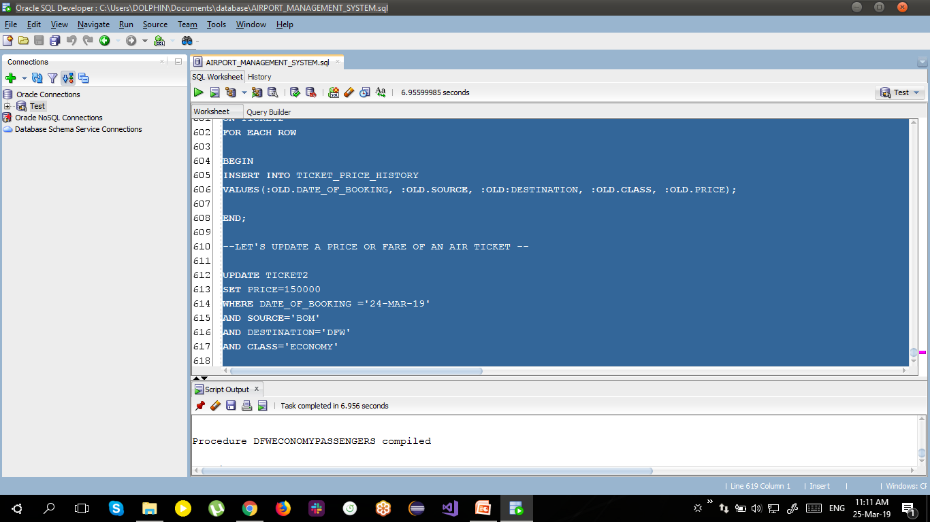

*Figure 2: Stored Procedure 1*

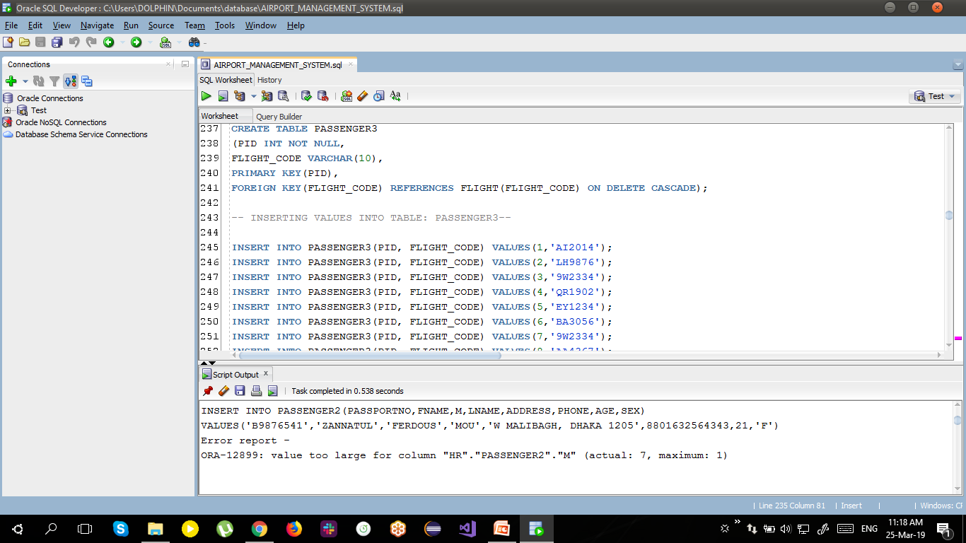

*Figure 3: Stored Procedure 1*

9.2 Stored Procedure for flight details by status

CREATE OR REPLACE PROCEDURE FLIGHTSBYSTATUS (IN_STATUS IN VARCHAR2) AS

CURSOR fSTATUS is

SELECT DISTINCT F.FLIGHT_CODE ,AL.AL_NAME ,F.ARRIVAL,F.DEPARTURE, F.SOURCE,F.DESTINATION,F.STATUS,F.FLIGHTTYPE

FROM AIRLINE AL,AIRPORT AP, FLIGHT F WHERE AL.AIRLINEID=F.AIRLINEID

AND F.STATUS =IN_STATUS;

FlightStatus fSTATUS%rowtype; BEGIN

Open fSTATUS ; LOOP

fetch fSTATUS into FlightStatus; EXIT WHEN fSTATUS%NOTFOUND;

DBMS_OUTPUT.PUT_LINE (FlightStatus.FLIGHT_CODE || ' ' || FlightStatus.AL_NAME || ' ' || FlightStatus.ARRIVAL || ' ' || FlightStatus.departure|| ' ' ||FlightStatus.Source || ' ' || FlightStatus.DESTINATION || ' ' || FlightStatus.STATUS || ' ' || FlightStatus.FLIGHTTYPE);

END LOOP;

CLOSE fSTATUS;

END FLIGHTSBYSTATUS;

--Testing in sql developer: Oracle db-- SET SERVEROUTPUT ON

exec FLIGHTSBYSTATUS('Delayed');

-- or--

SET SERVEROUTPUT ON

exec FLIGHTSBYSTATUS('On-time');

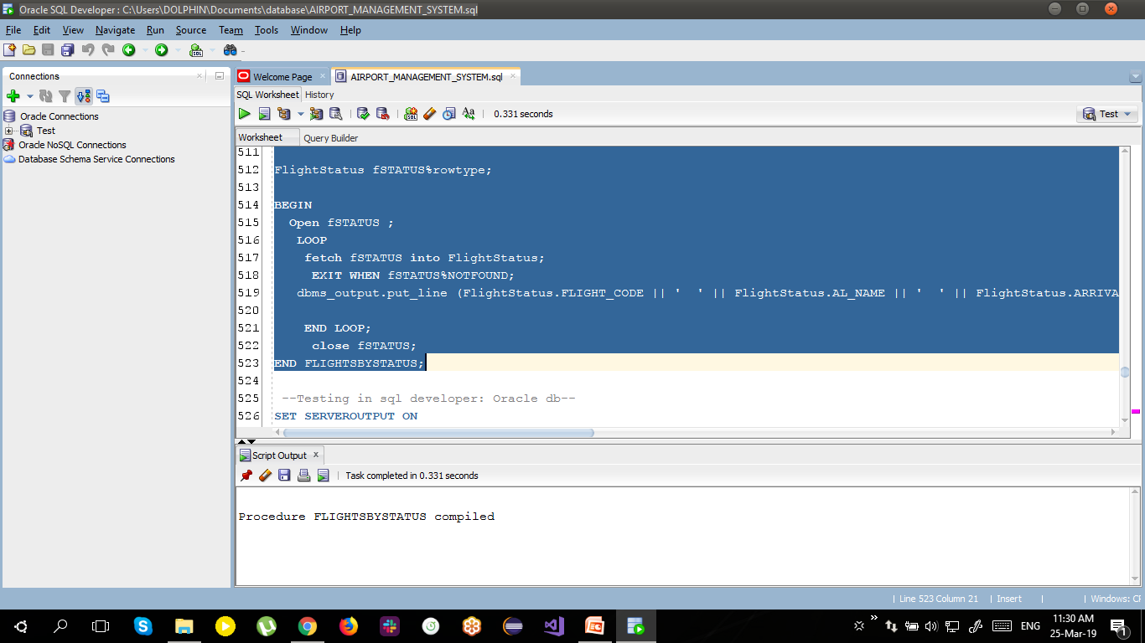

*Figure 4: Stored Procedure 2*



*Figure 5: Stored Procedure 2*

# TRIGGERS

* + 1. 10.1 Trigger for, when a flight is delayed, it is logged into different tables.

CREATE OR REPLACE TRIGGER DELAYEDFLIGHTS AFTER INSERT ON FLIGHT

FOR EACH ROW

BEGIN

IF UPDATING('STATUS') THEN

INSERT INTO DELAYED_FLIGHTS (FLIGHT_CODE, SOURCE, DESTINATION , AIRLINEID ,REPORT_TIME) VALUES(:NEW.FLIGHT_CODE,:NEW.SOURCE,:NEW.DESTINATION,:NEW.AIRLINEID,sysdate);

END IF;

END;

-- This is audit table for this trigger-- CREATE TABLE DELAYED_FLIGHTS (FLIGHT_CODE VARCHAR2(20), DESTINATION VARCHAR2(20), SOURCE VARCHAR2(20),

AIRLINEID VARCHAR2(20), REPORT_TIME DATE);

INSERT INTO FLIGHT(FLIGHT_CODE, SOURCE, DESTINATION, ARRIVAL, DEPARTURE, STATUS, DURATION, FLIGHTTYPE, LAYOVER_TIME, NO_OF_STOPS, AIRLINEID) VALUES('QR129','BOM','DFW','02:10','03:15','Delayed','24hr','Connecting',3,1,'AI);

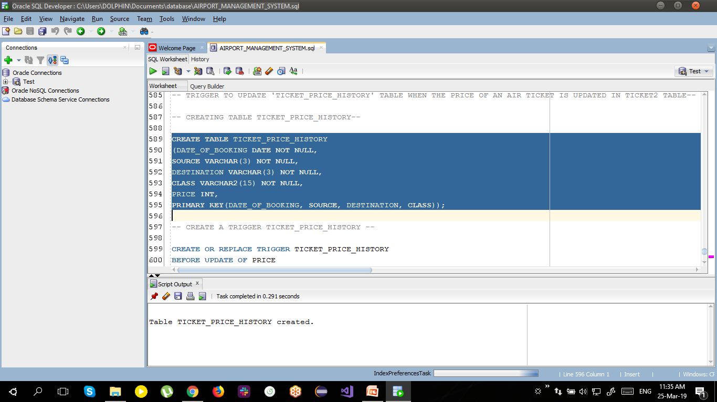

*Figure 6: Trigger 1*

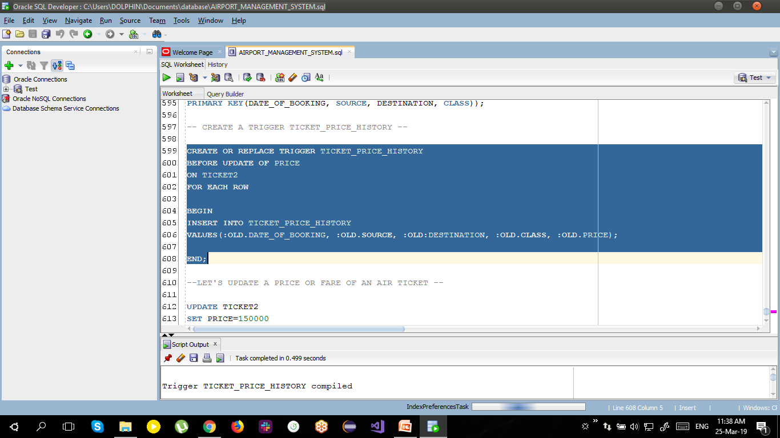

*Figure 7: Trigger 1*

10.2 Trigger to update TICKET_PRICE_HISTORY table when the price of the air ticket is updated in TICKET2 table.

-- CREATING TABLE TICKET_PRICE_HISTORY--

CREATE TABLE TICKET_PRICE_HISTORY (DATE_OF_BOOKING DATE NOT NULL, SOURCE VARCHAR(3) NOT NULL, DESTINATION VARCHAR(3) NOT NULL, CLASS VARCHAR2(15) NOT NULL, PRICE INT,

PRIMARY KEY(DATE_OF_BOOKING, SOURCE, DESTINATION, CLASS));

-- CREATE A TRIGGER TICKET_PRICE_HISTORY --

CREATE OR REPLACE TRIGGER TRIGG_TICKET_PRICE_HISTORY BEFORE UPDATE OF PRICE

ON TICKET2 FOR EACH ROW

BEGIN

INSERT INTO TICKET_PRICE_HISTORY

VALUES(:OLD.DATE_OF_BOOKING, :OLD.SOURCE, :OLD.DESTINATION, :OLD.CLASS, :OLD.PRICE); END;

--LET'S UPDATE A PRICE OR FARE OF AN AIR TICKET --

UPDATE TICKET2 SET PRICE=150000

WHERE DATE_OF_BOOKING ='24-MAR-19' AND SOURCE='DAC'

AND DESTINATION='DFW' AND CLASS='ECONOMY'

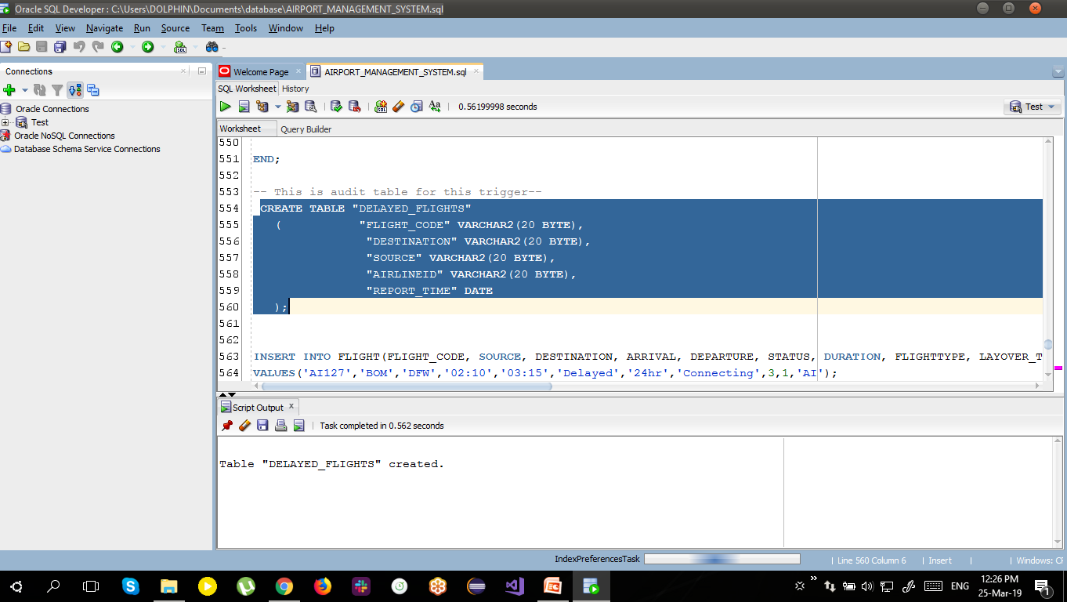

*Figure 8: Trigger 2*

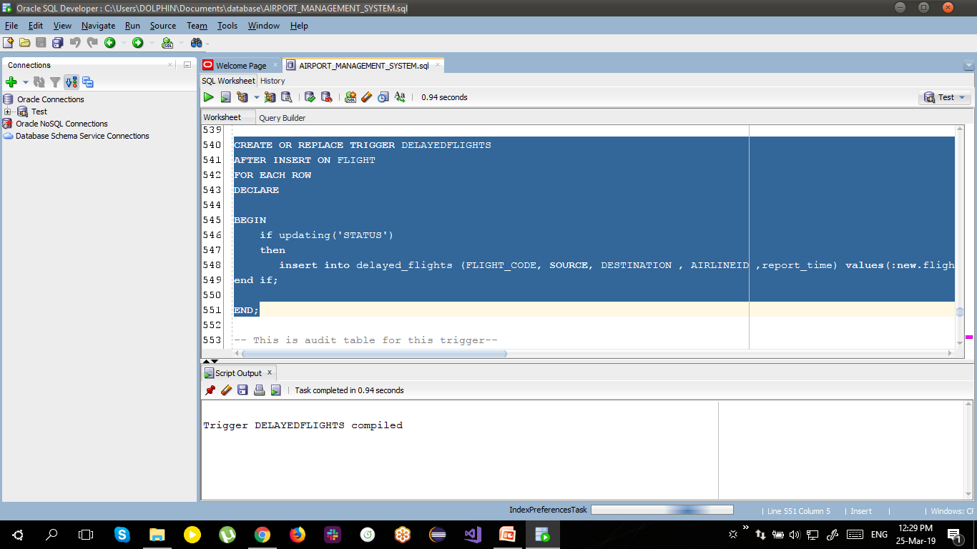

*Figure 9: Trigger 2*

# BUSINESS RULES

* + 1. 11.1 The length of an air ticket number should be exactly 13 digits.

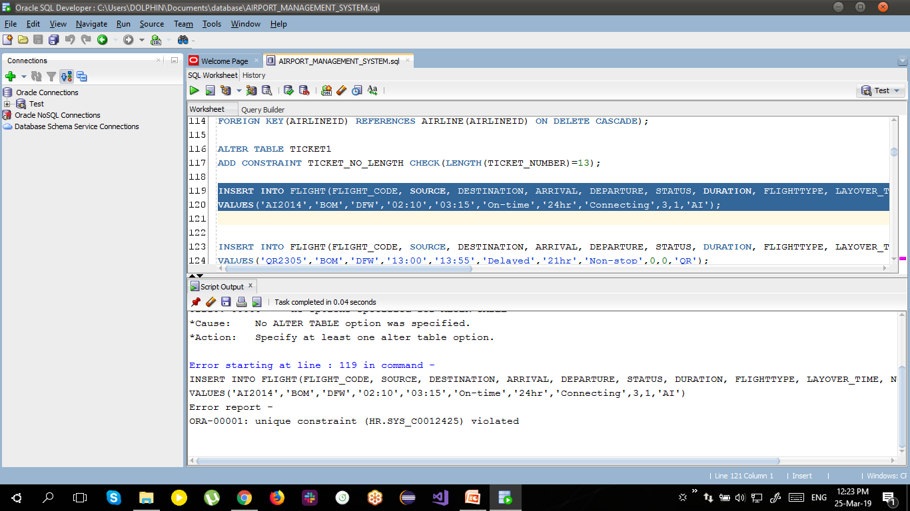

*Figure 10: Business Rule 1*

* + 1. 11.2 Age of an employee working at any airport should not be greater than 65.

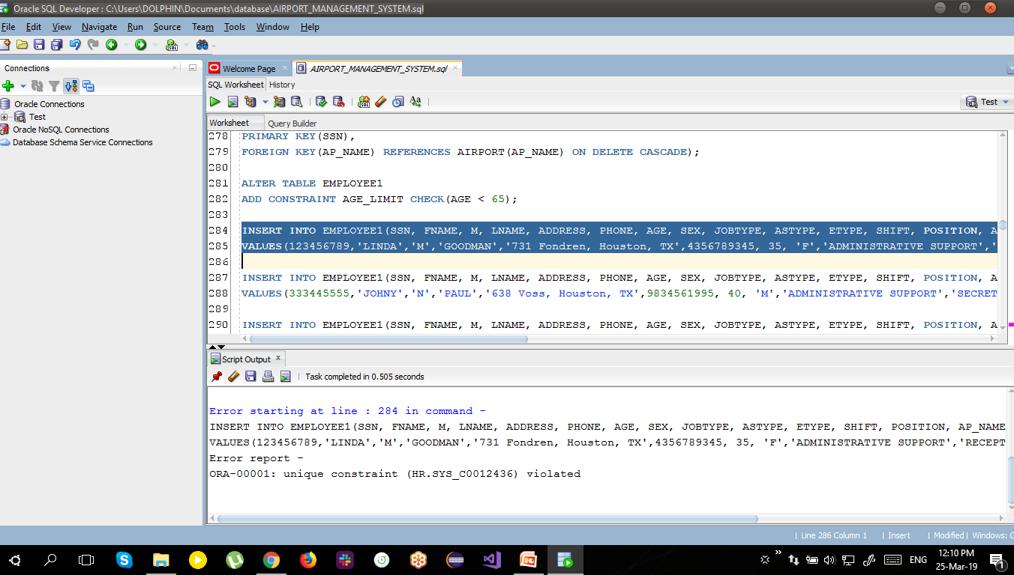

*Figure 10: Business Rule 2*